**DevOps**

**********************************************************************************

**Introduction**

**********************************************************************************



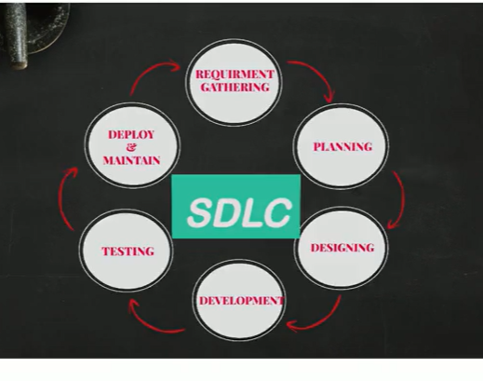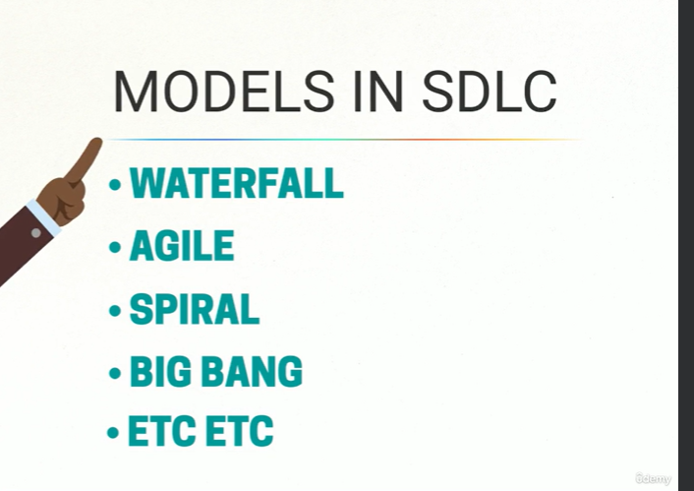

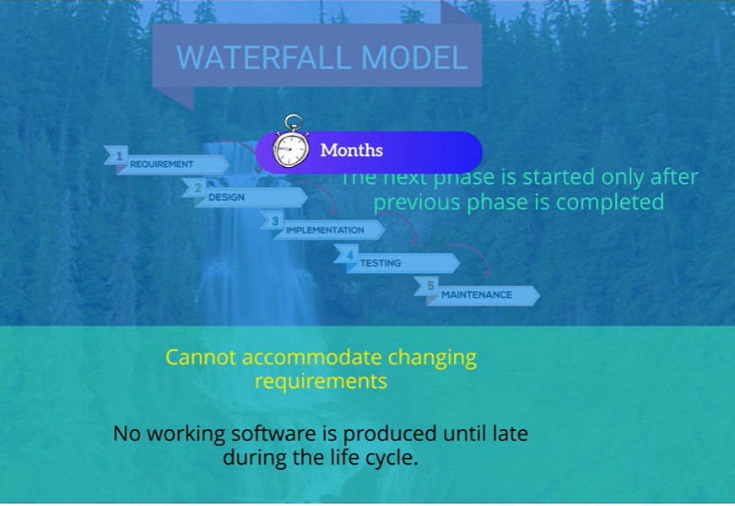

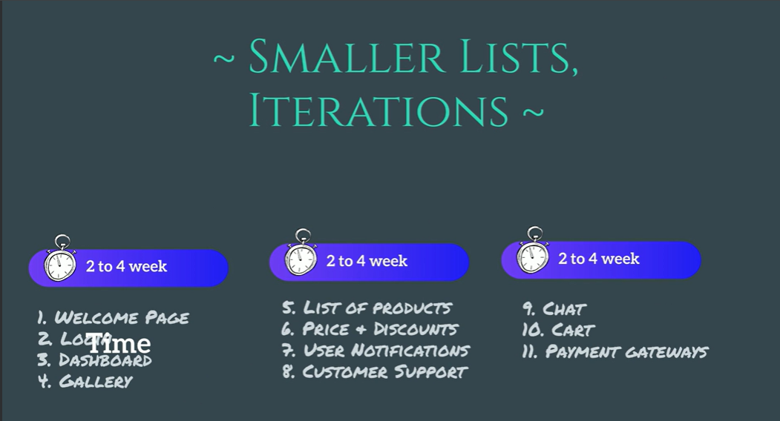

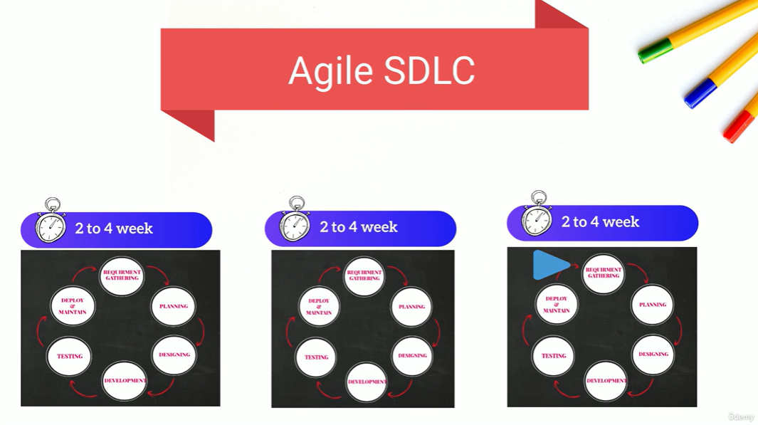



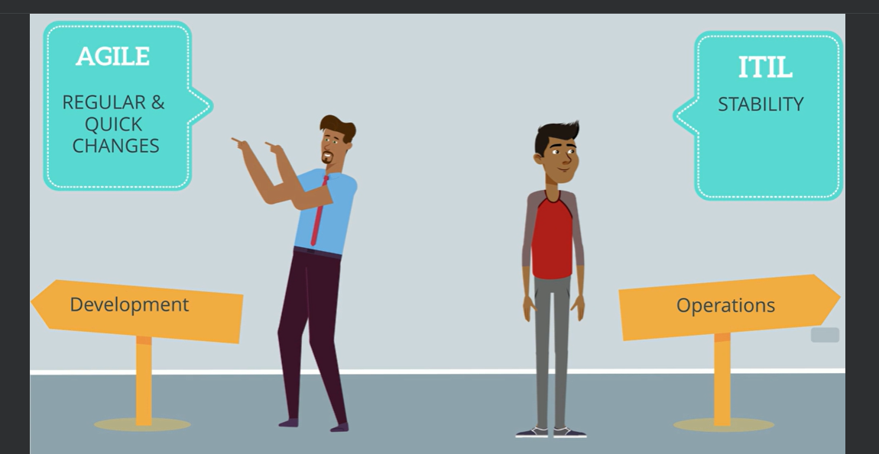





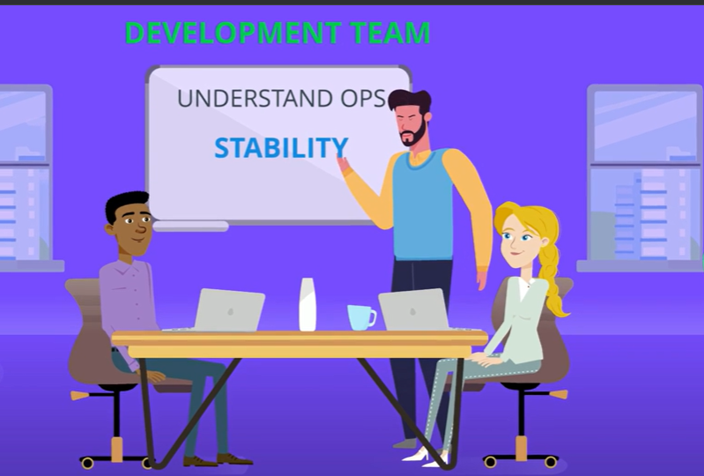







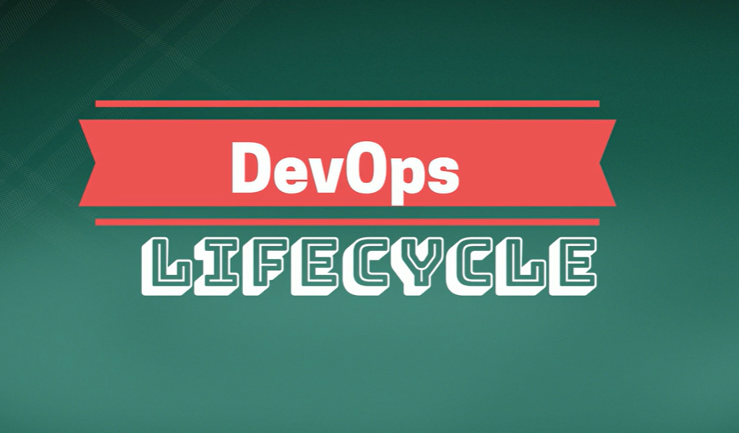

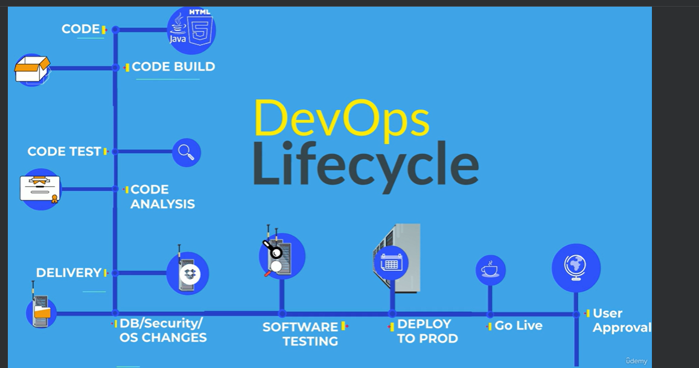



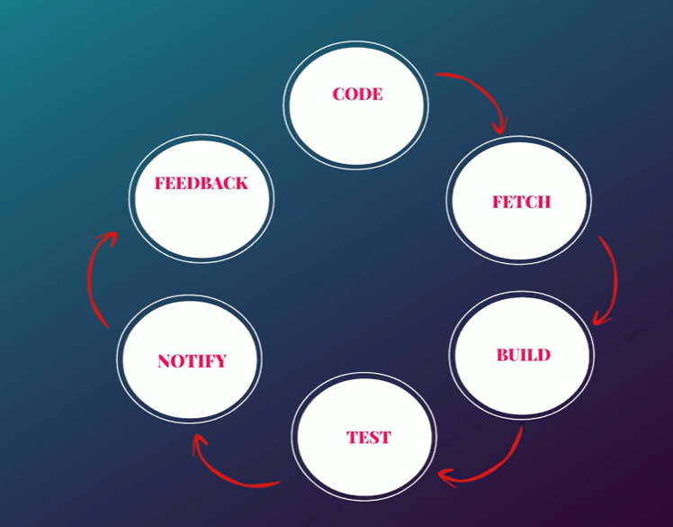

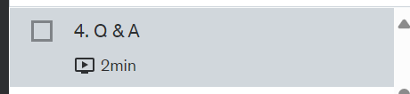

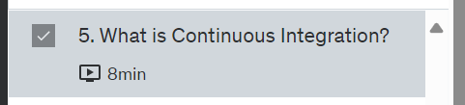





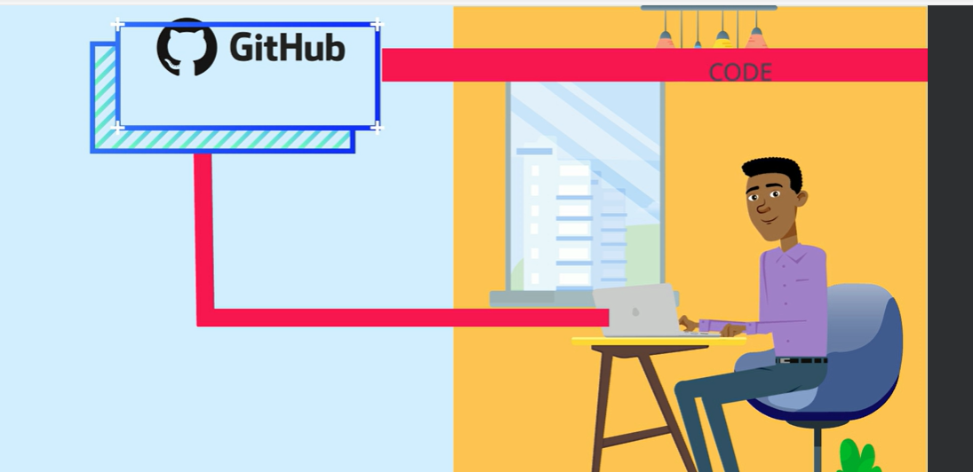

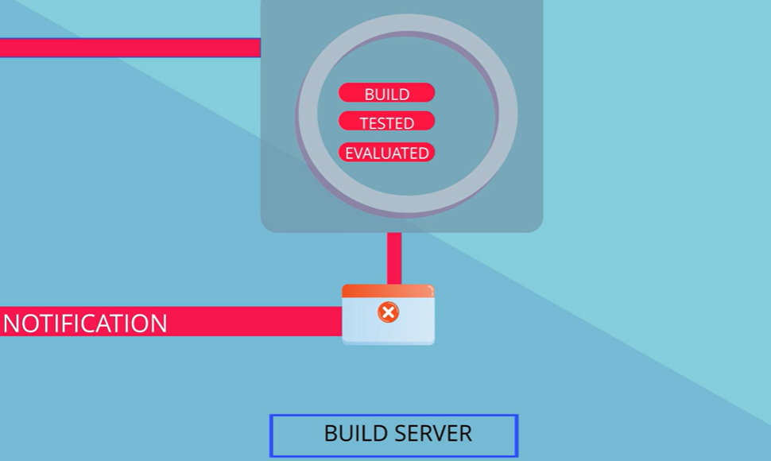



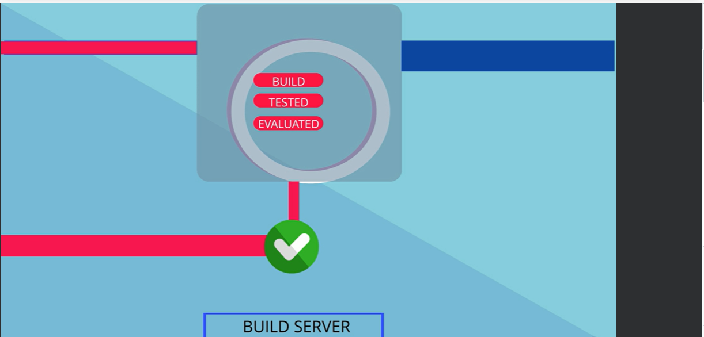

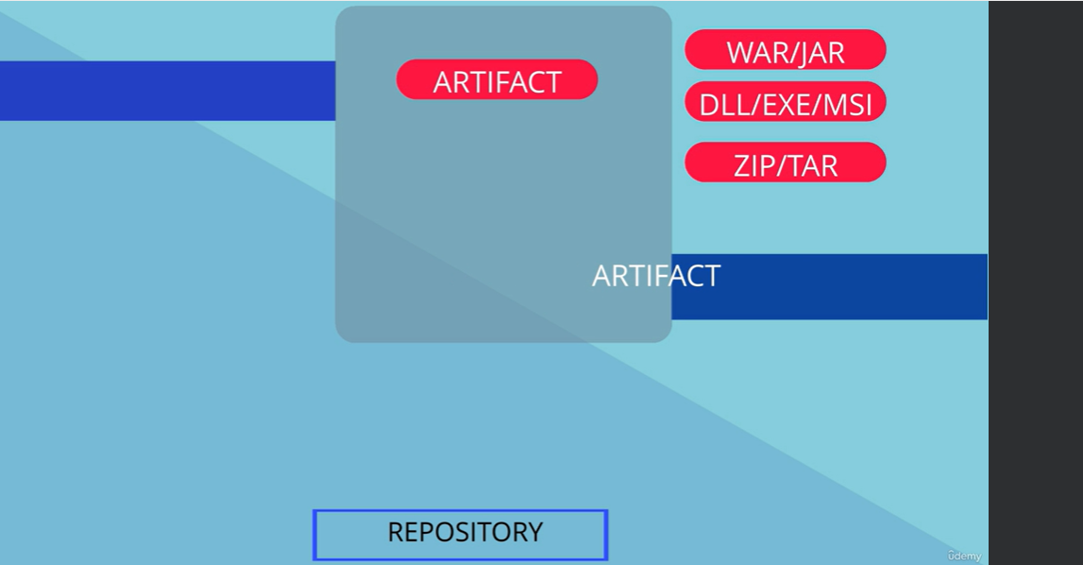



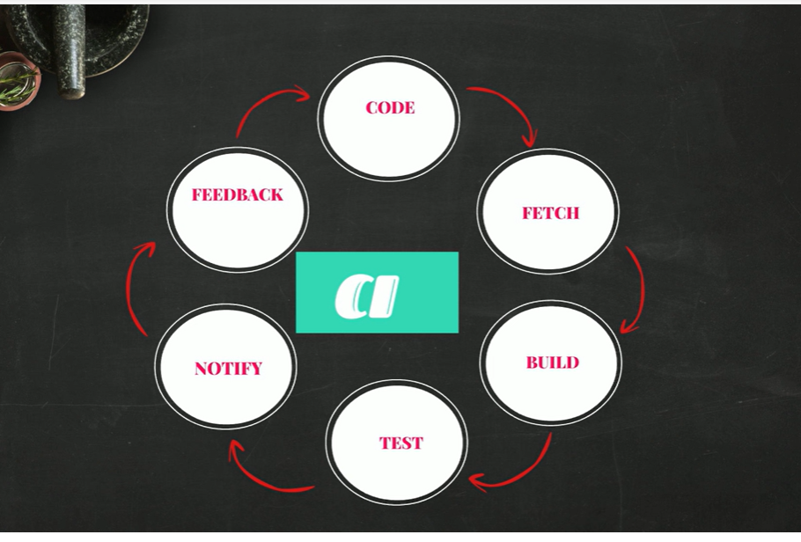

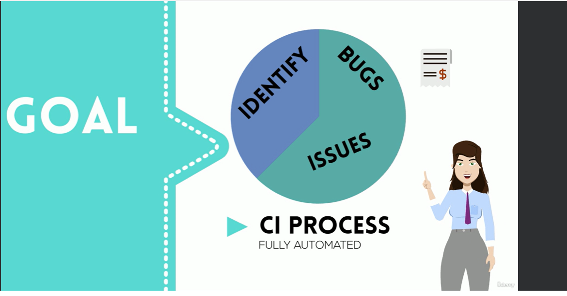

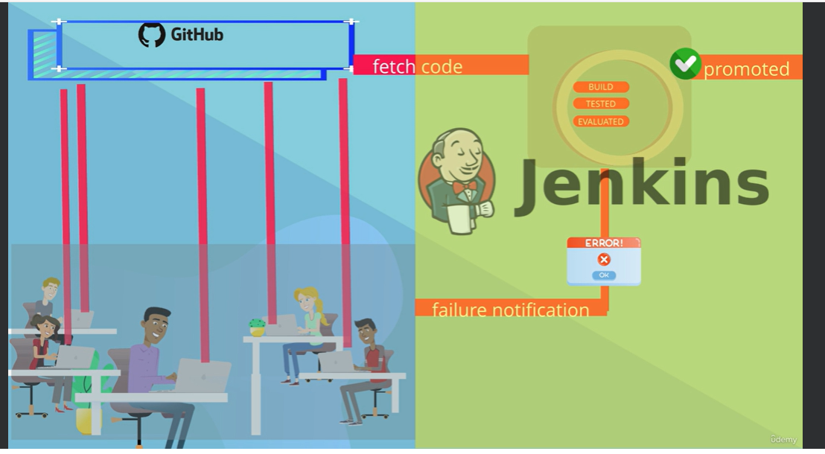

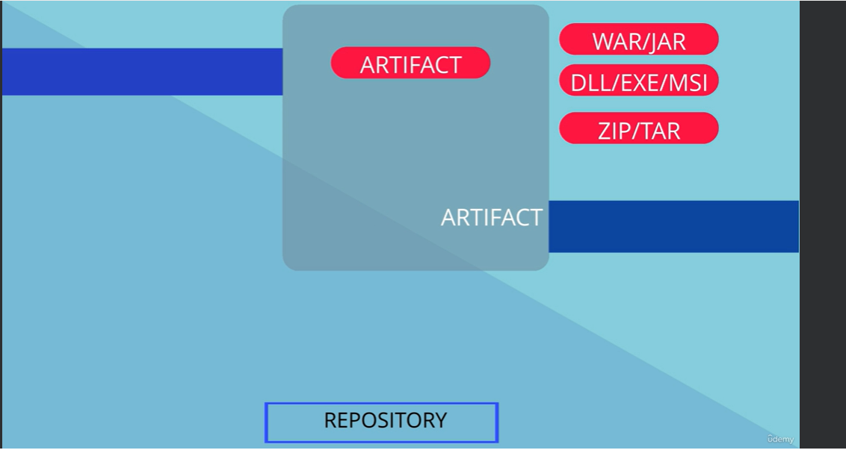













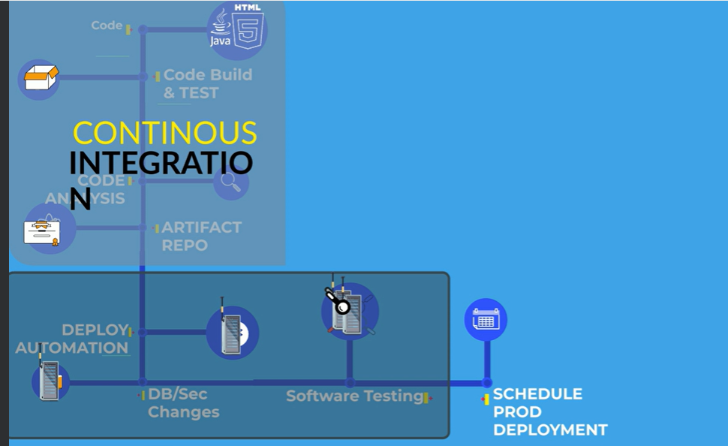

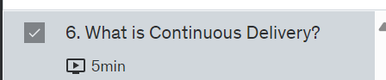

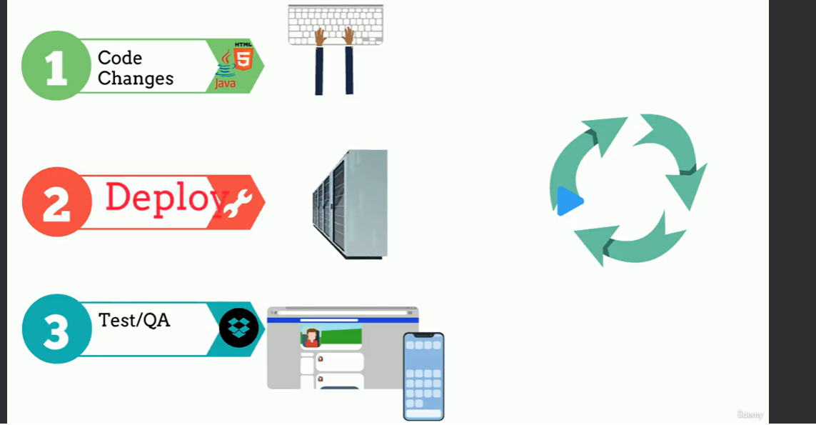

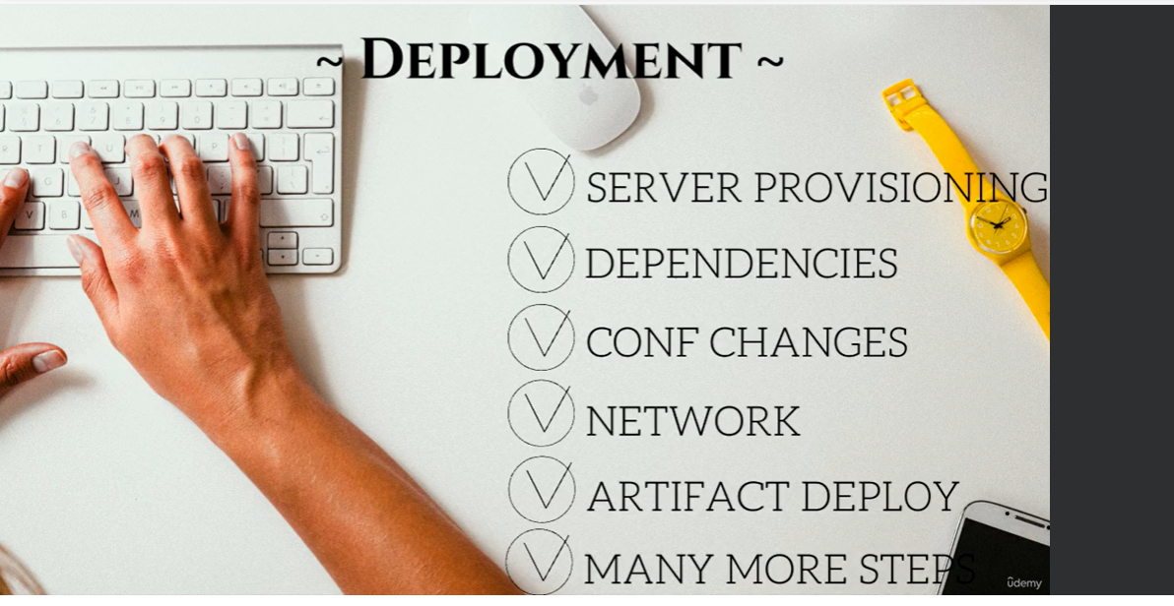





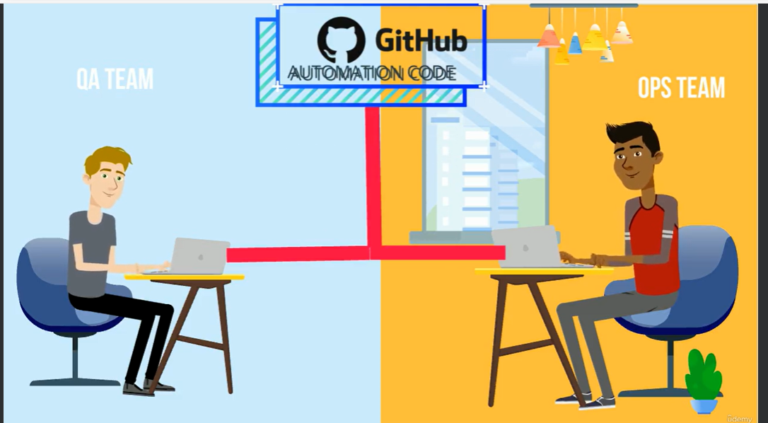

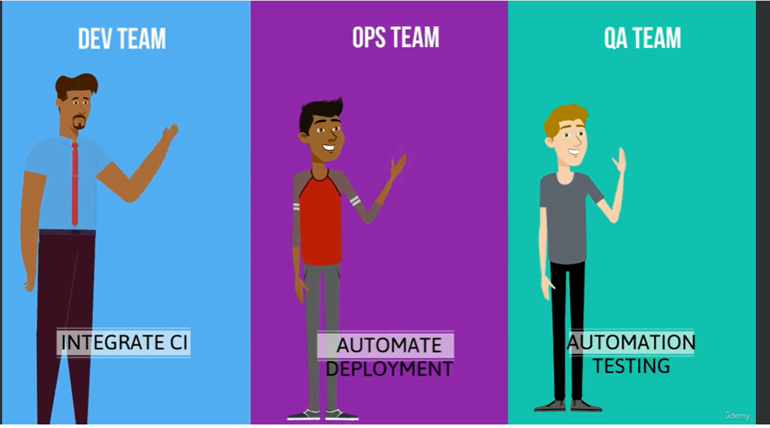

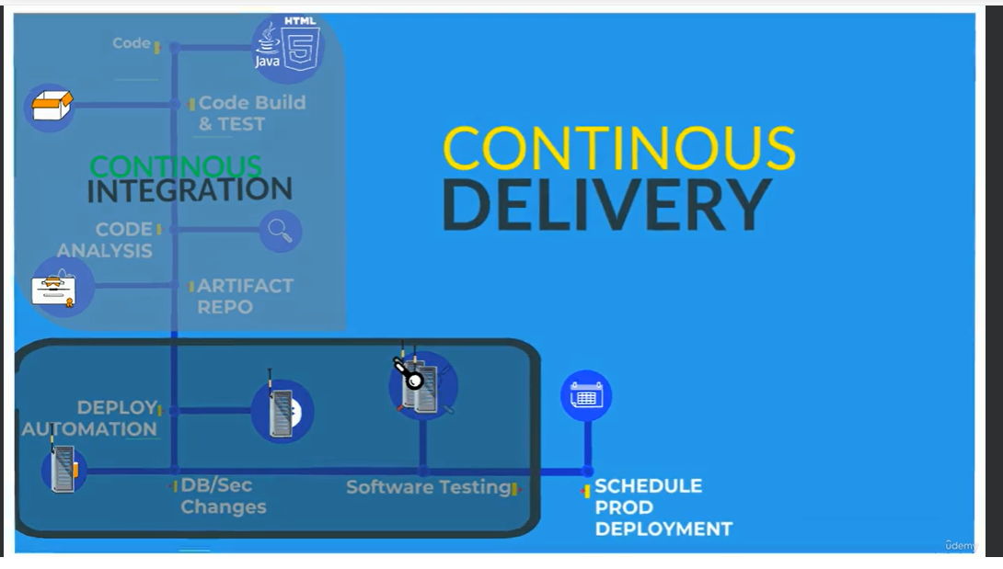

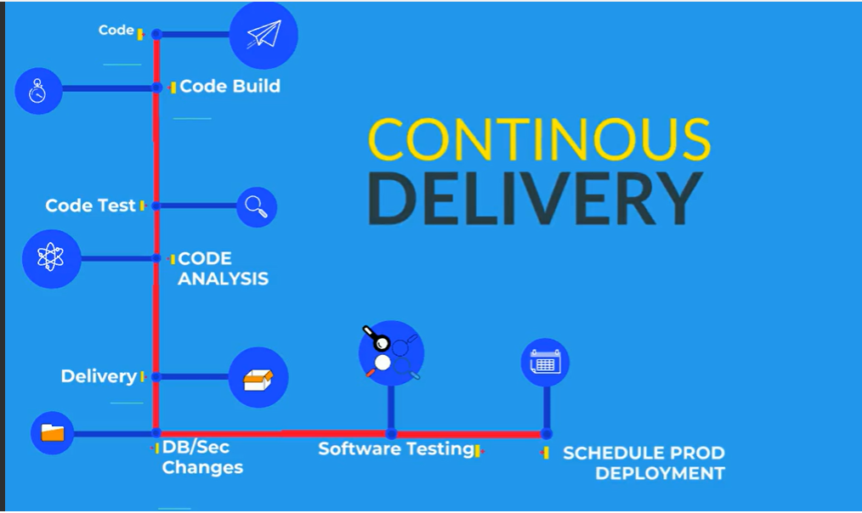

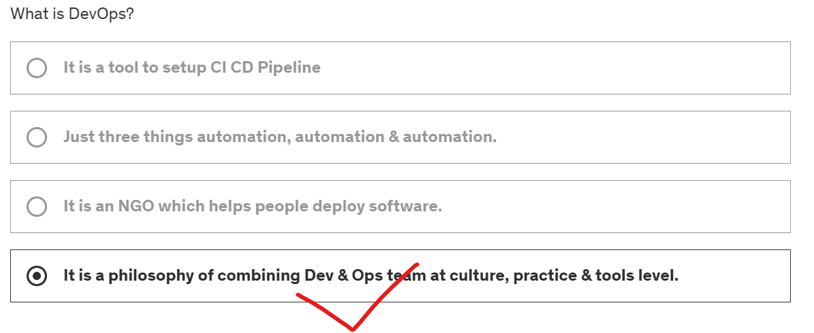

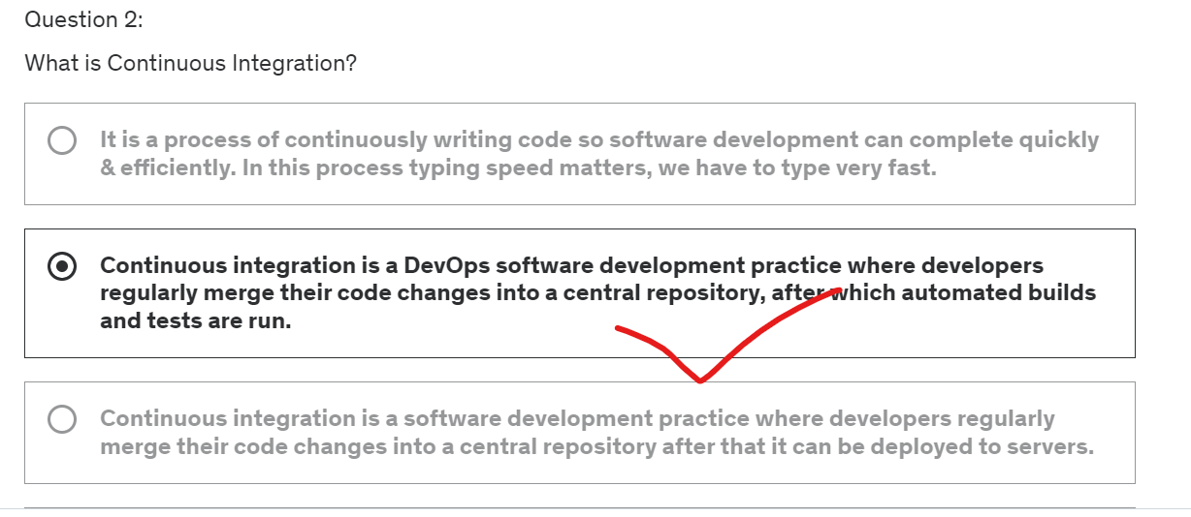

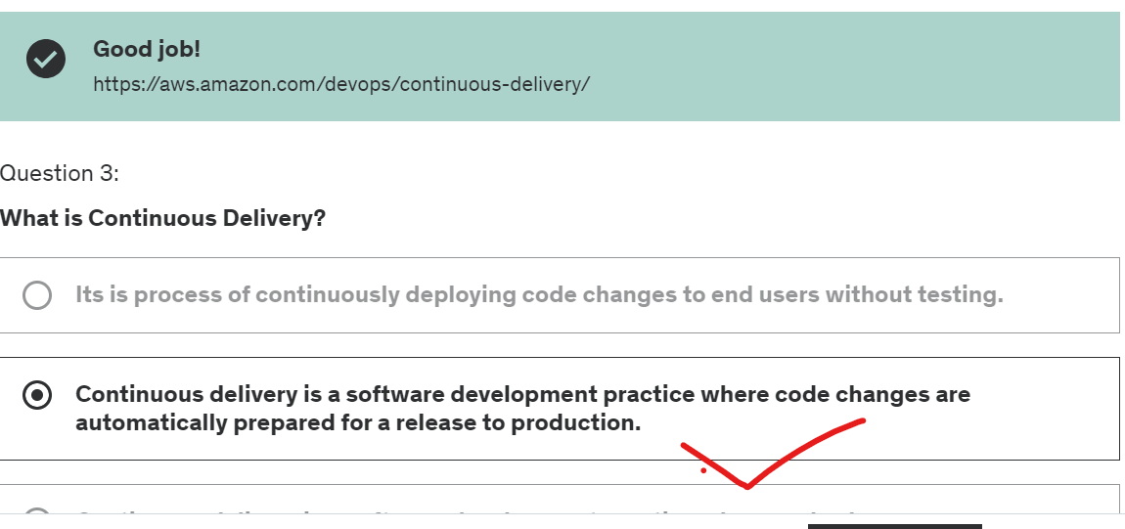



[GitHub - imnowdevops/ddc-material](https://github.com/imnowdevops/ddc-material)

Chocolety—> windows for shell script command window

Homebrew—for mac os command line for develops

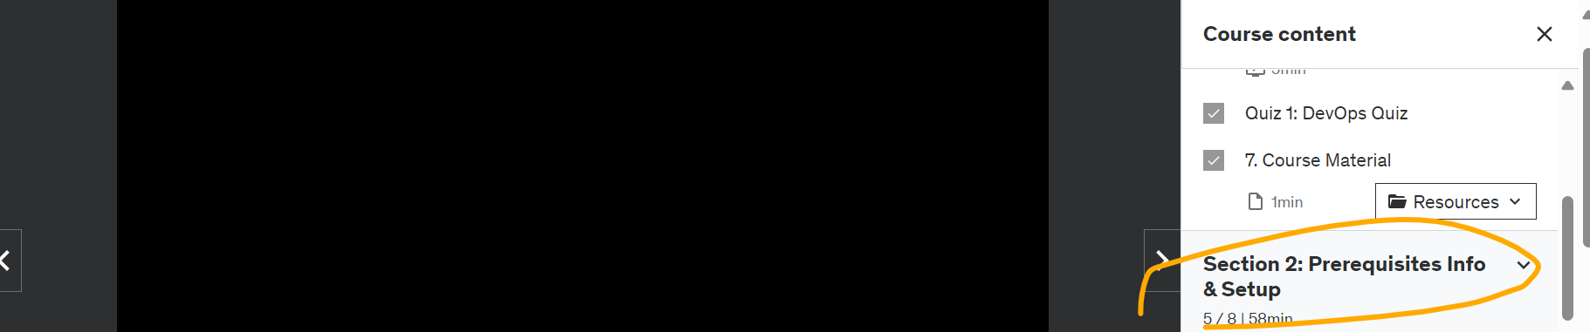

Choco installa maven -y

Choco install awscli -y

Choco install intelijidea -community -y

Choco install vscode -y

Choco install sublimetext3.app -y

**Tools Prerequisites for Ubuntu 20**

#### ****Tools Prerequisites for Ubuntu 20****

**Install Virtualbox**

$ sudo apt update

$ sudo apt install virtualbox -y

**Install Vagrant**

$ curl -O <https://releases.hashicorp.com/vagrant/2.2.9/vagrant_2.2.9_x86_64.deb>

$ sudo apt install ./vagrant_2.2.9_x86_64.deb

**Install Git**

$ sudo apt install git -y

**Install jdk8**

$ sudo apt-get install openjdk-8-jdk -y

**Install Maven**

$ sudo apt-get install maven -y

**Install awscli**

$ sudo apt-get install awscli -y

**Install Intellij community**

$ sudo snap install intellij-idea-community --classic

**Install Sublime Text**

$ sudo apt update

$ sudo apt install dirmngr gnupg apt-transport-https ca-certificates software-properties-common

$ curl -fsSL https://download.sublimetext.com/sublimehq-pub.gpg | sudo apt-key add -

$ sudo add-apt-repository "deb https://download.sublimetext.com/ apt/stable/"

$ sudo apt install sublime-text -y

EC2: stands for

